**CyberPSG User manual**

Contents

Installation 3

Data 4

Montages 5

Selecting a montage 5

Montage management 7

Channels 8

Channels top menu 8

Channels window 10

Channel timeline navigation 11

Time jump 11

Real-time mode 12

Video window 13

Annotations 14

Annotation management 14

Working with annotations 17

Annotation navigator 19

Filters 20

Analytics 22

Small data analysis 22

FFT 23

Spectrogram 24

Converting data and annotations from JSON file formats to MEF3 and XML 25

Settings 26

Export 26

Import 26

Video 27

Channels 28

# Installation

CyberPSG comes as binaries that only works on MS Windows 10 desktops. To install it please follow these simple instructions

1. Start CyberPSG.exe
2. Press Options to choose installation folder

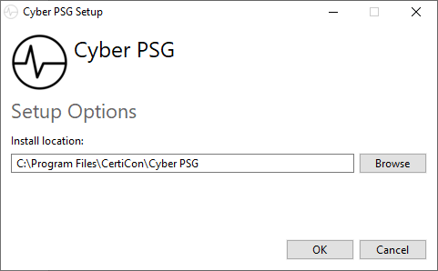

1. Read and agree the license terms and press Install
2. Press close after installation is finished

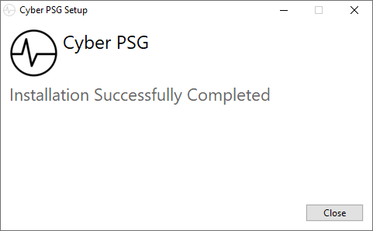

# Data

CyberPSG can currently open only MEF3 file format.

To open data, follow the steps below.

1. Run Cyber PSG
   1. Press File -> Open -> Browse and choose base data folder (*.mefd) to load
   2. Choose file from Recently opened section

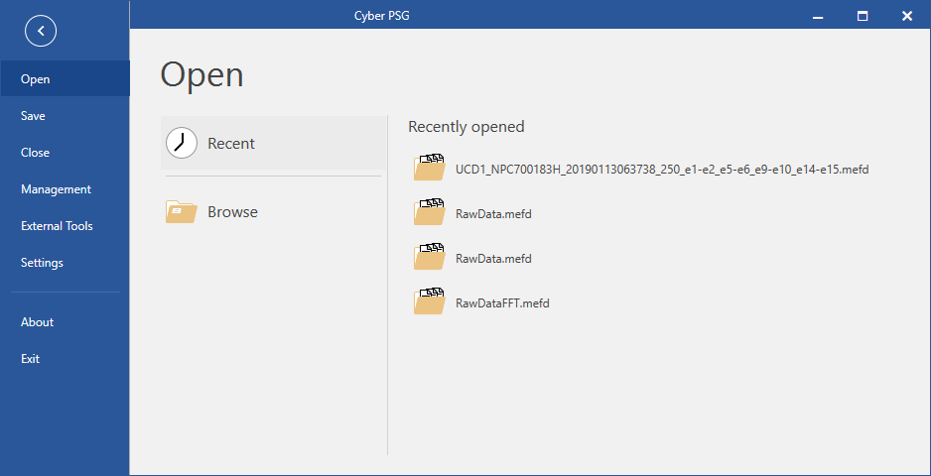

# Montages

Montages provide setup for channels, their visibility, layout and parameters.

## Selecting a montage

CyberPSG supports user defined montages of channels that can be created by default or modified by the user. To create a default montage, follow the steps below:

1. Press Select montage

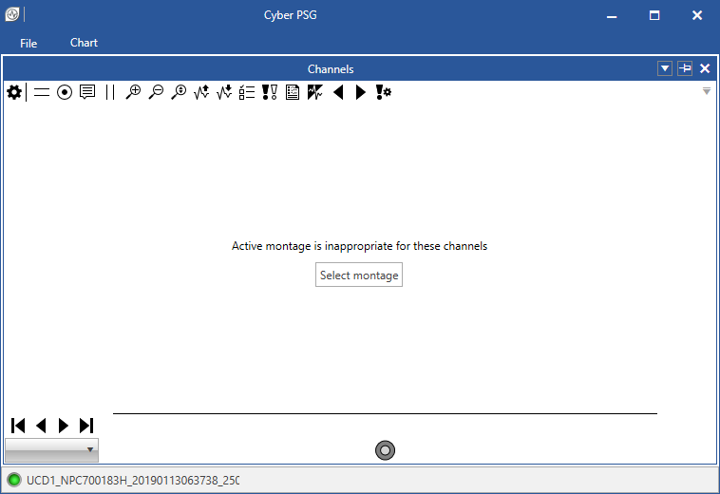

1. “Create default” montage or “select from the list” if any is already created

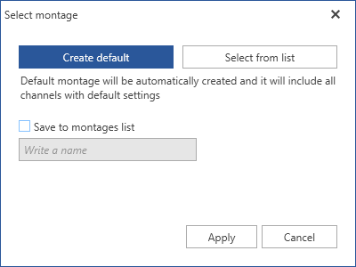 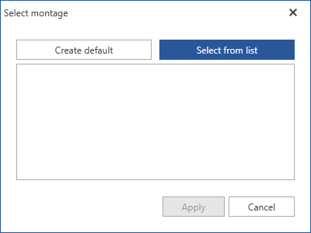

1. Press Apply
2. If montage is created successfully, the data are loaded and displayed

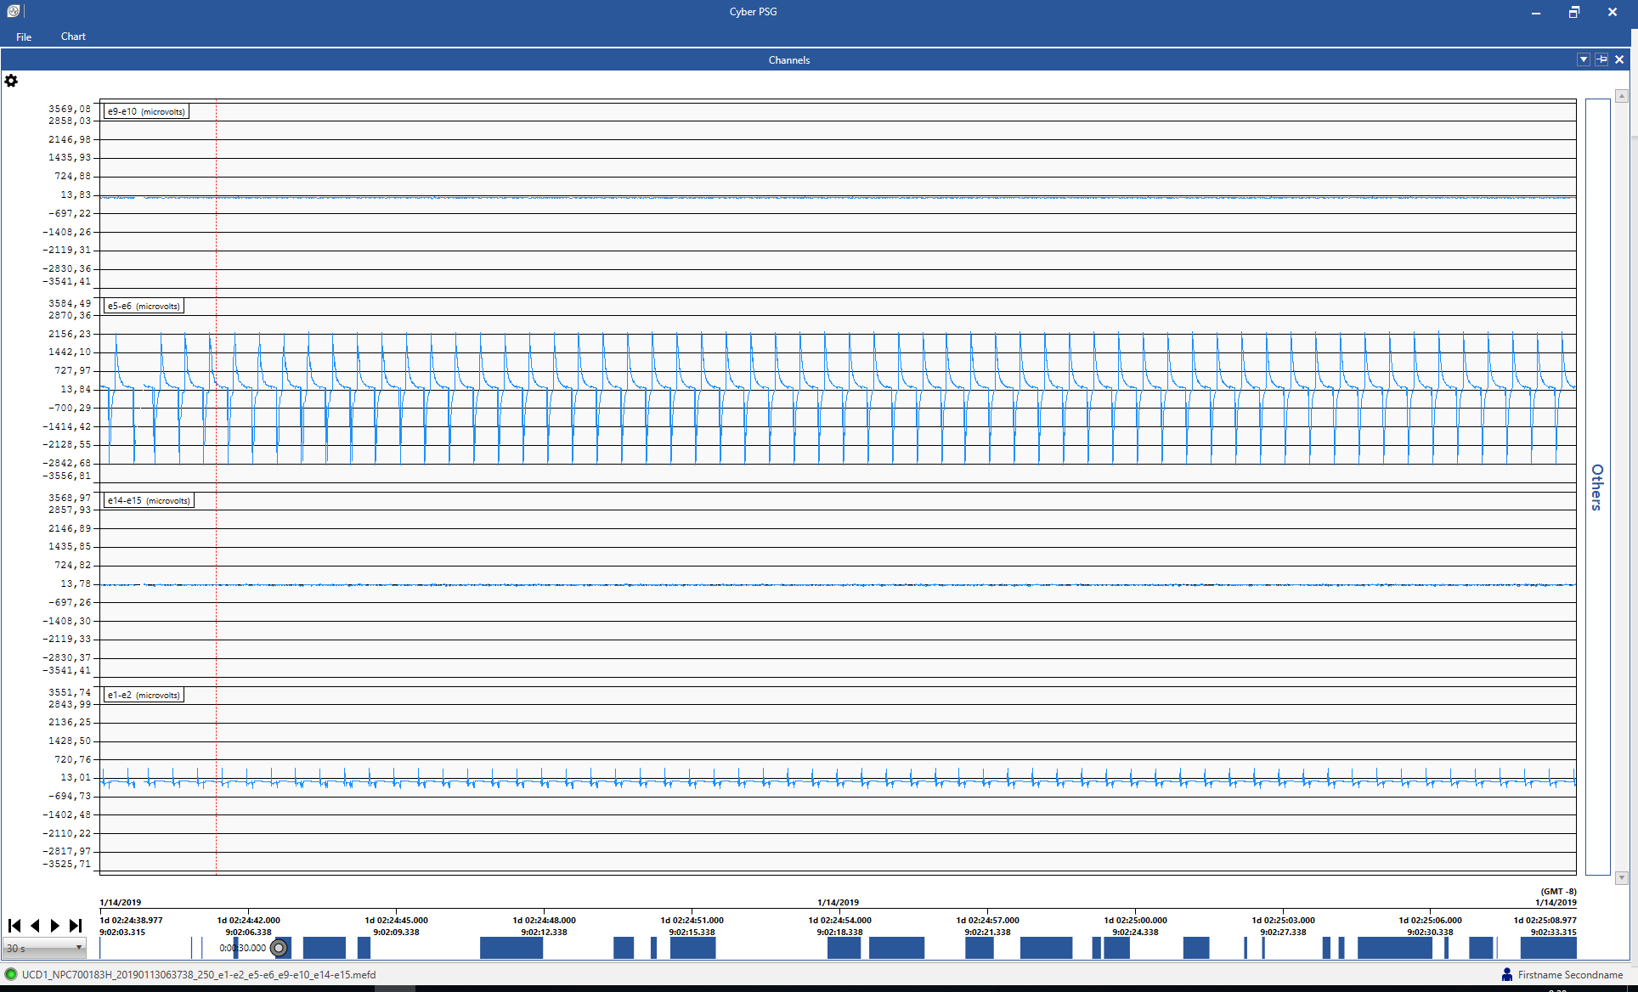

## Montage management

Montage management contains the list of available montages and their setup. User can add/remove channels and modify channel parameters such as color, group and visibility.

1. Press File -> Management -> Montage management to open Montage management
2. Create/delete montages on the left side
3. Update montages, add/delete/update channels on the right side of the screen
4. Manage Time window lengths and channel groups for each montage

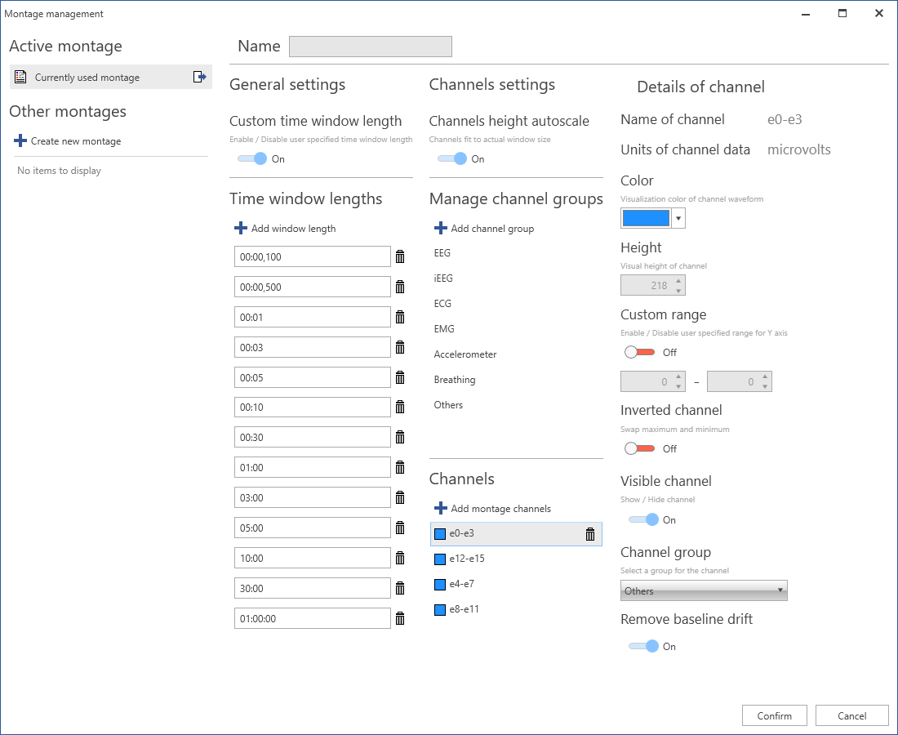

# Channels

Channels displays loaded data and basic actions to work with data in Channels top menu and Channel timeline navigation.

## Channels top menu

Channels top menu provides the basic actions to work with data and annotations.

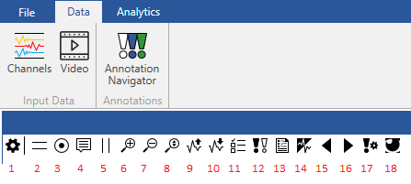

1. Open/Close top menu with controls
2. Enable/Disable horizontal lines
3. Enable/Disable cursor marker
4. Enable/Disable cursor tooltip
5. Enable/Disable vertical lines
6. Increase channel chart height
7. Decrease channel chart height
8. Reset channel chart height
9. Zoom channel Y axis in
10. Zoom channel Y axis out
11. Select channels to show

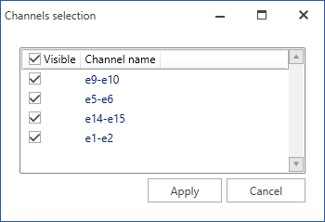

1. Enable/Disable displaying of an annotation
2. Select montage

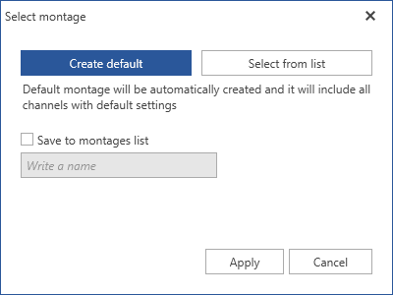

1. Filter manager
2. Go to previous annotation
3. Go to next annotation
4. Annotation manager
5. Start/Stop Real-time mode

## Channels window

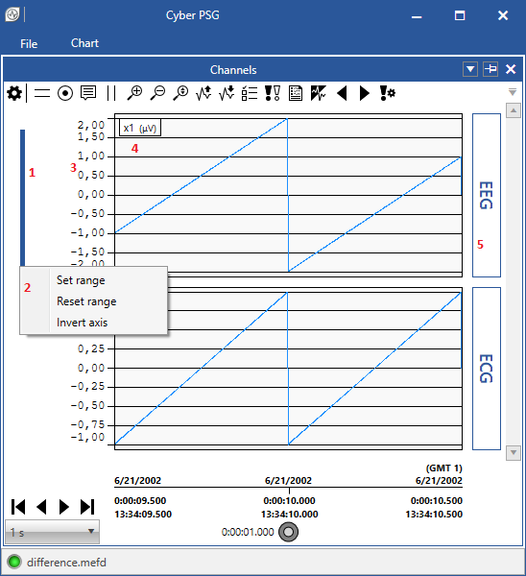Channels window displays the data, information about groups and axis, and some actions to work with the displayed data.

1. Double left-click on the left side of channel to select one channel
2. Right click on the left side of channel to call context menu to Set range, Reset range or Invert axis for selected channel
3. Y axis of signal
4. Name of the signal and units
5. Group of the signal

## Channel timeline navigation

Channel timeline navigation gives the information about the actual position in the signal and contains actions to move forward or backward in the data, perform accurate jumps in time and choose the displayed area.



1. Move to the beginning window.
2. Move to the previous time window.
3. Move to the next time window.
4. Move to the end of file window.
5. Choose the time window width.
6. Shows the date of the position in data
7. Shows the relative time since the beginning of the measurement
8. Shows an absolute time with GMT offset.
9. Shows actual window width
10. Shows where are the data (blue bars) are in the whole measurement

### Time jump

It is possible to perform accurate jumps in time by right-click on the timeline or by pressing hotkey Ctrl+G to open the “Time jump” window and set the desired time in human-readable or POSIX format in microseconds.

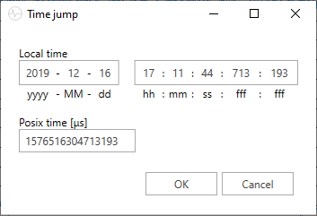

## Real-time mode

CyberPSG allows a user to view continuously collected data. This feature is called real-time mode. To start the real-time mode, click on the “Start Real-time mode” action in the Channels top menu. When the action is selected, a dialog is displayed which allows the user to set up a few parameters of the real-time mode before the actual start.

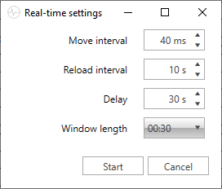

Move interval - Sets how often is the visible range moved and the time increment of the move (40 ms equals to 25Hz).

Reload interval - Sets how often new data are buffered.

Delay - Sets a delay time. It is recommended to set a delay to ensure that data are already properly saved to MEF3 file.

Window length - Sets a time window width for the real-time mode. It is not possible to change it when the real-time is turned on.

Note: Setting a very small interval in combination with wide time window and/or viewing data with several or more channels may result in performance issues and causing that the real-time mode will not be running in actual real time (the move interval may take longer but the increment remains accurate).

When real-time is running, there are few user interface changes:

* It is not possible to change the visible range on X axis.
* The slider on X axis is hidden.
* Manual movement in data is disabled, the moving in data is automatic based on the move interval.
* Creating an annotation using mouse is disabled. However, it is possible to create an annotation using a keyboard shortcut.
* The “Start Real-time mode” action changes to “Stop Real-time mode” and allows the user to stop the running real-time mode.
* A dialog with a progress bar may appear indicating that data are being buffered. It is possible the stop the real-time by selecting the cancel option in the dialog.
* When the collecting of data that are being displayed stops, a dialog informs the user that no new data was detected, and the real-time mode is canceled automatically.

# Video window

If the data includes video in video folder (setup is located in Settings -> Video as described in section Settings), then user can view the video synchronized with the raw data. And page forward/backward and do video playback.

1. To view the Video, video files must be named by YYYYMMDDhhmmss.avi/mp4 where

YYYY – Year

MM – Month

DD – Day

hh – Hour

mm – Minute

ss – Second of the beginning of the video file (first frame).

1. Press Data ->Video to open Video module.

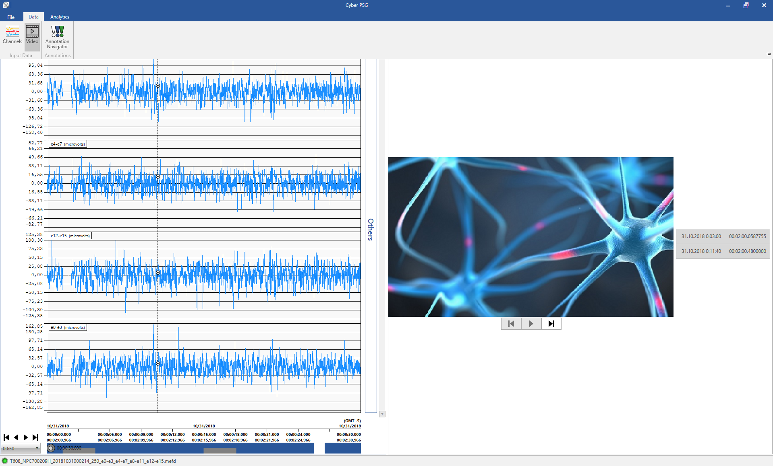

1. Select the video on the right side of the video module or jump to next/previous video using the buttons. Channels data will jump to corresponding position automatically.
2. To play the video, press the play button. The marker in chart window will move as the video plays.

# Annotations

Annotations are marking for important parts of data in signal. CyberPSG allows manually create, update and remove annotations or import them from XML file.

## Annotation management

Annotation management allows creating/modifying/removing Annotation groups, types and filters. User can also export/import Annotation data to/from XML format.

1. Press File -> Management -> Annotation management -> Annotation groups to create new, update, delete annotation groups and hypnogram annotations.

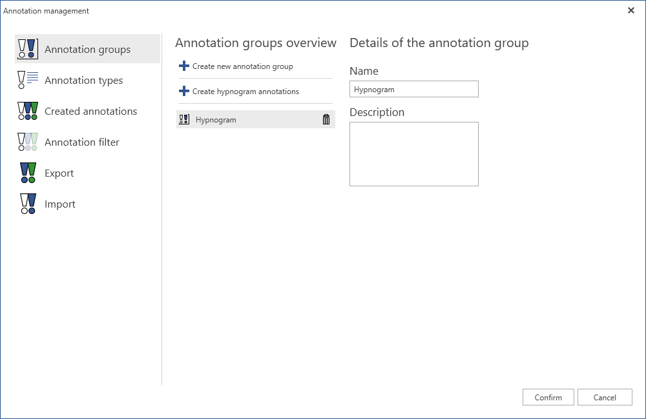

1. Press File -> Management -> Annotation management -> Annotation types to create new, update, delete annotation types and associate them to Annotation groups.

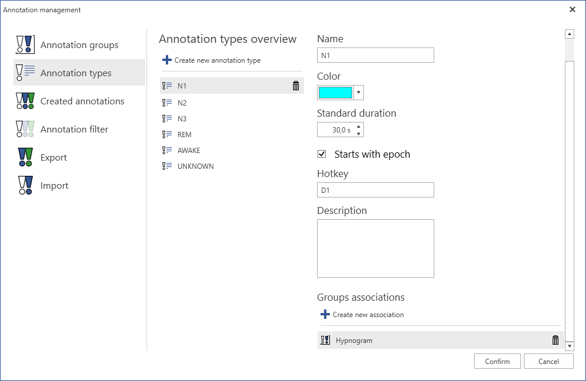

1. Press File -> Management -> Annotation management -> Annotation filter to set filters for annotations.

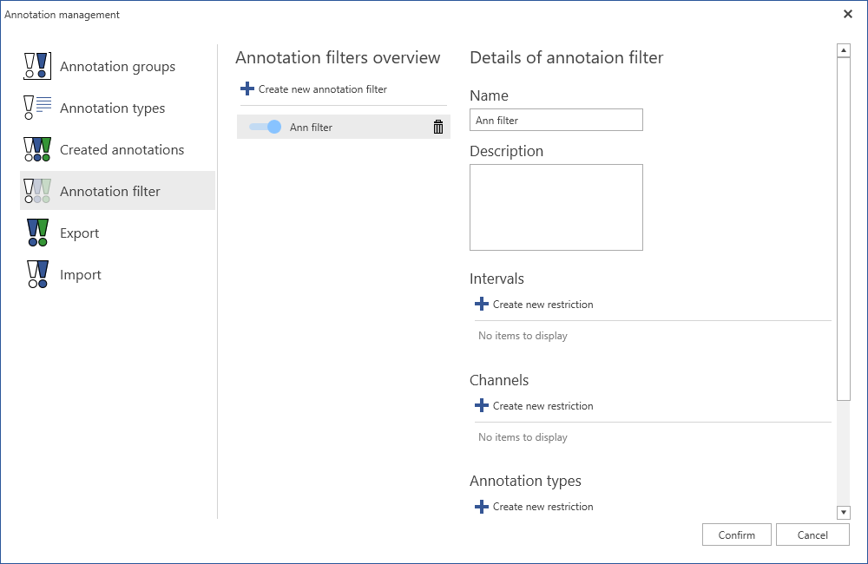

1. Press File -> Management -> Annotation management -> Export to export annotations to an xml file. It is possible to export only annotations, groups and types restricted by Annotation filter.

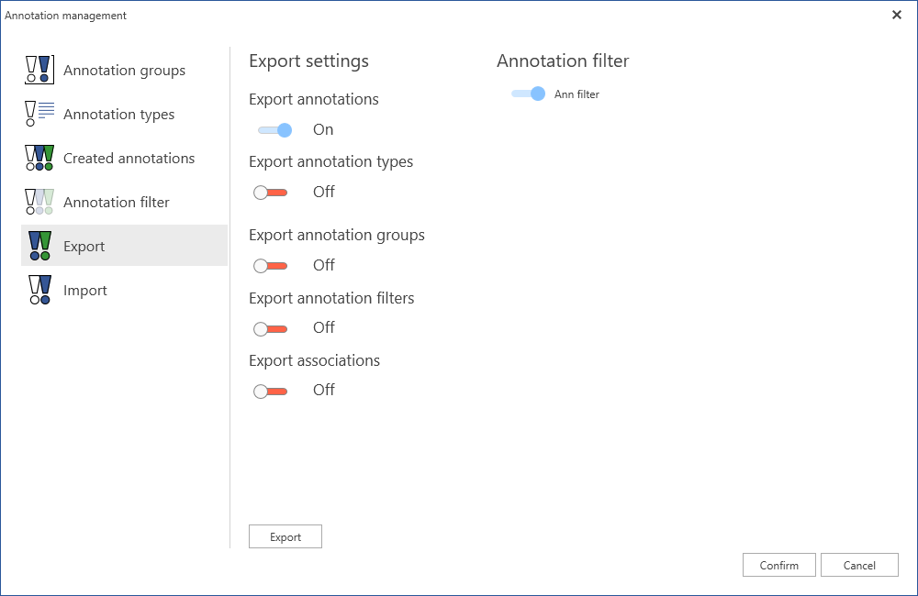

1. Press File -> Management -> Annotation management -> Import to import annotations from an xml file. It is possible to import only annotations, groups and types restricted by Annotation filter.

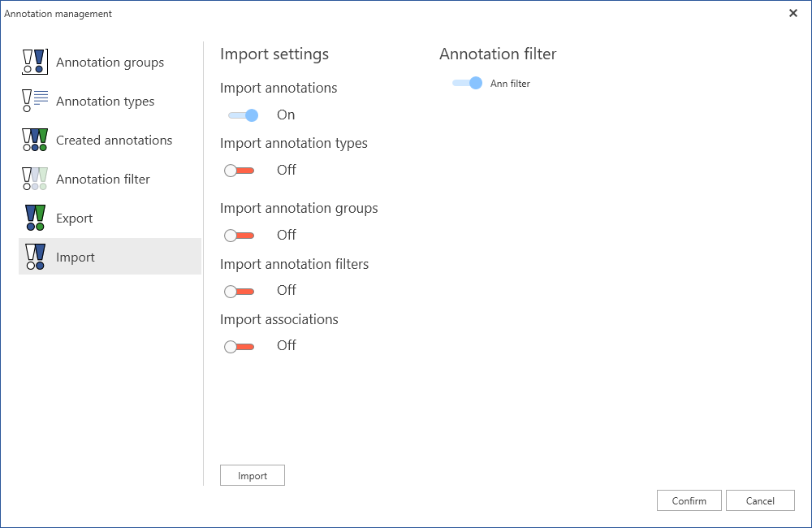

## Working with annotations

1. To create an annotation, go to Annotation management and create Annotation type as described in previous section.
2. Right click in the main Channel window and select any annotation type.

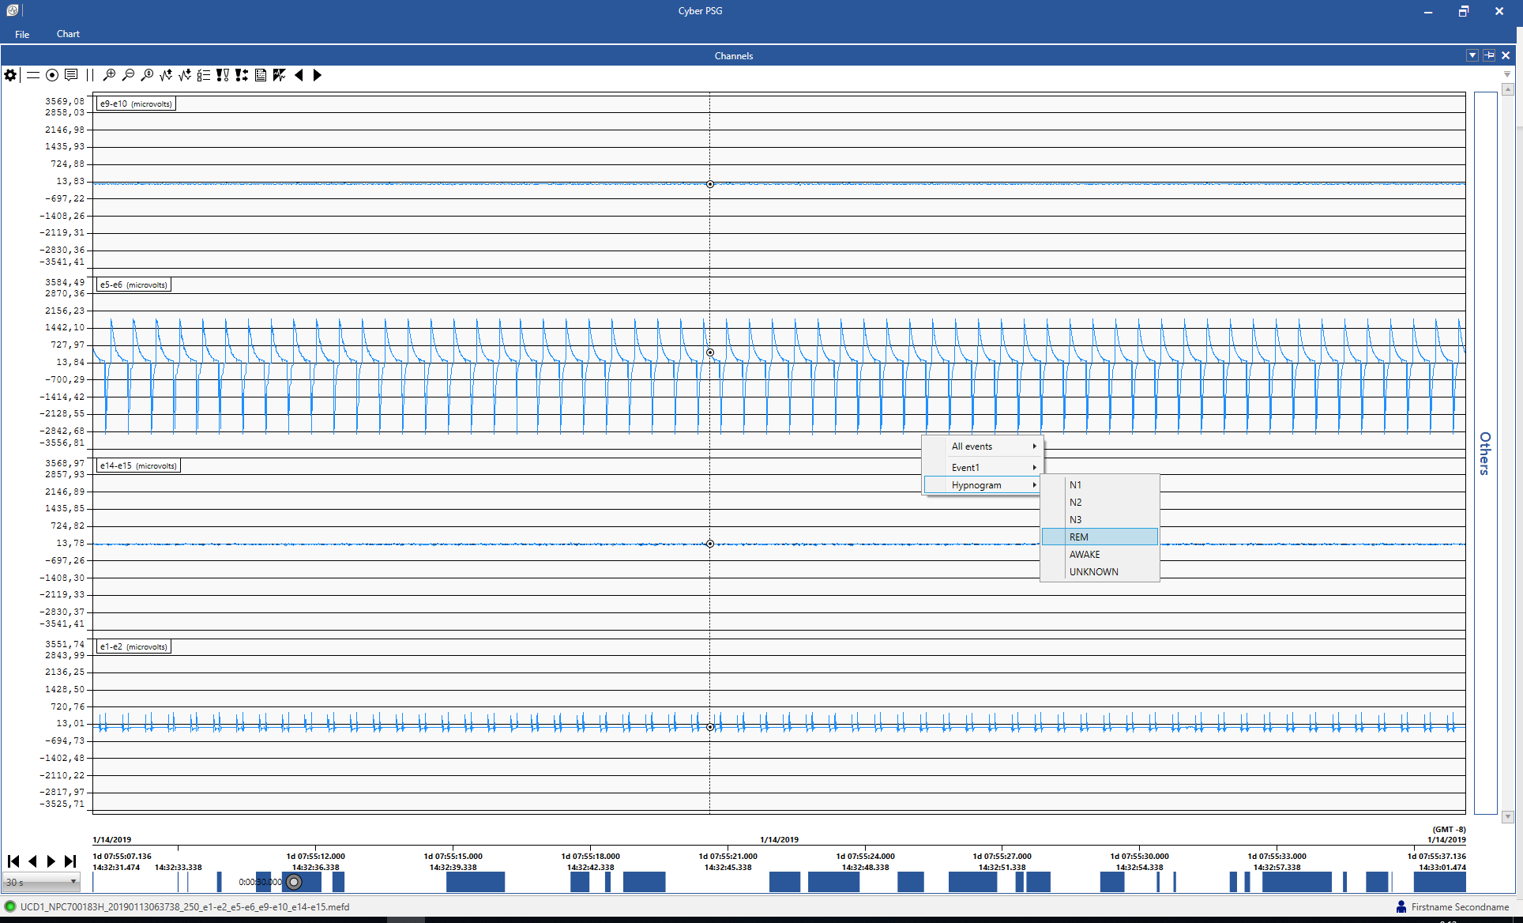

1. Right-click, hold and drag to create an annotation for a specific time period (Hypnogram annotations can start only on 0/30 sec position).

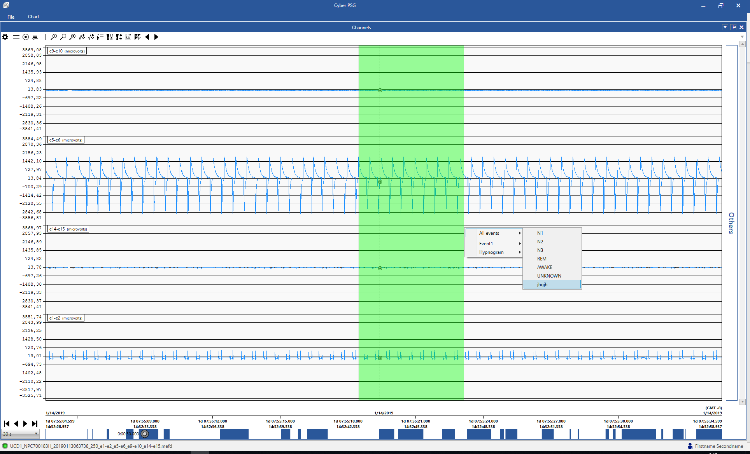

1. Double left-click on the left side of the y-axis to select a single channel and add an annotation only for this channel.

Note: Hypnogram annotations are created only for all channels.

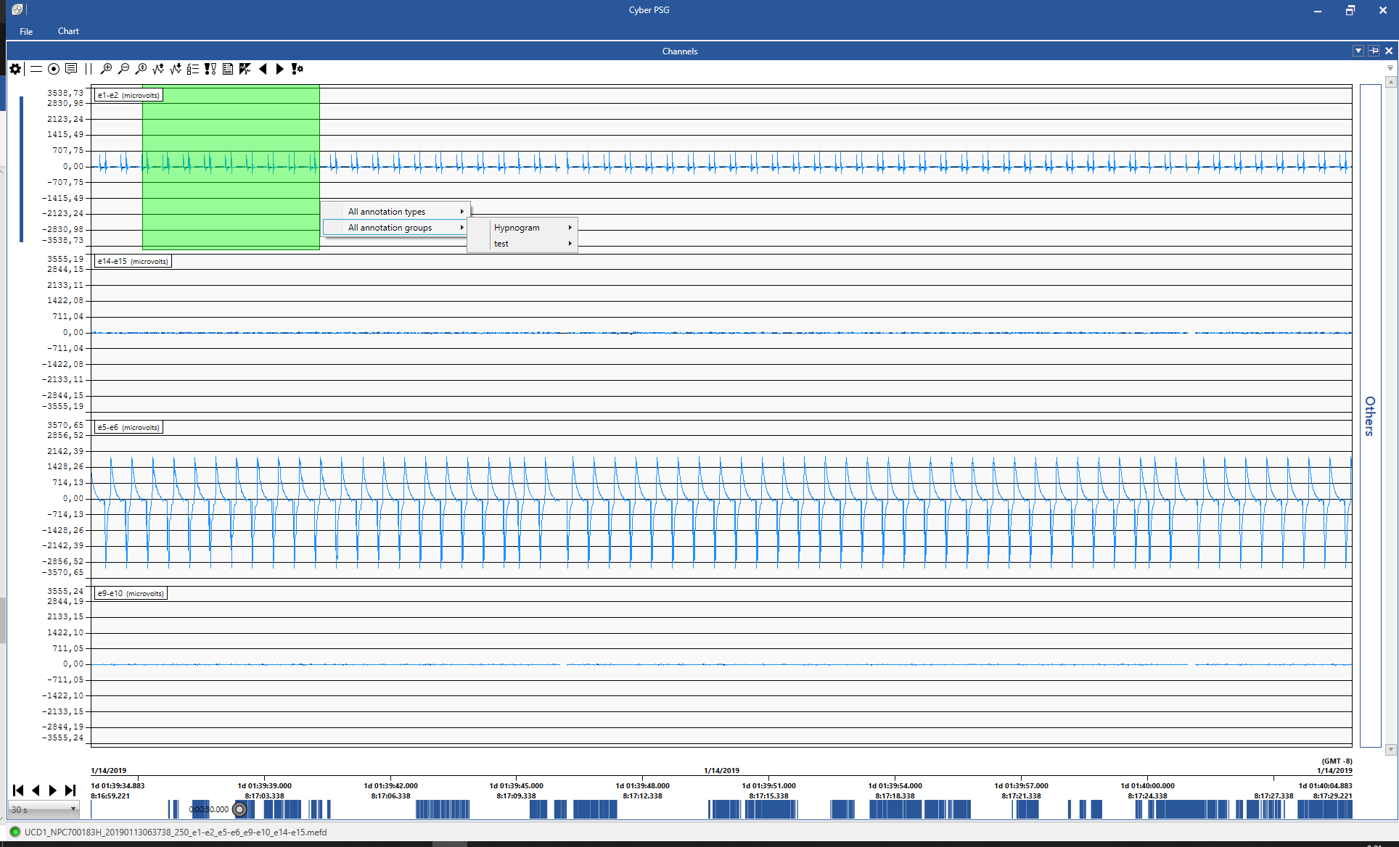

1. Right click on the header of an Annotation to edit/delete the annotation.

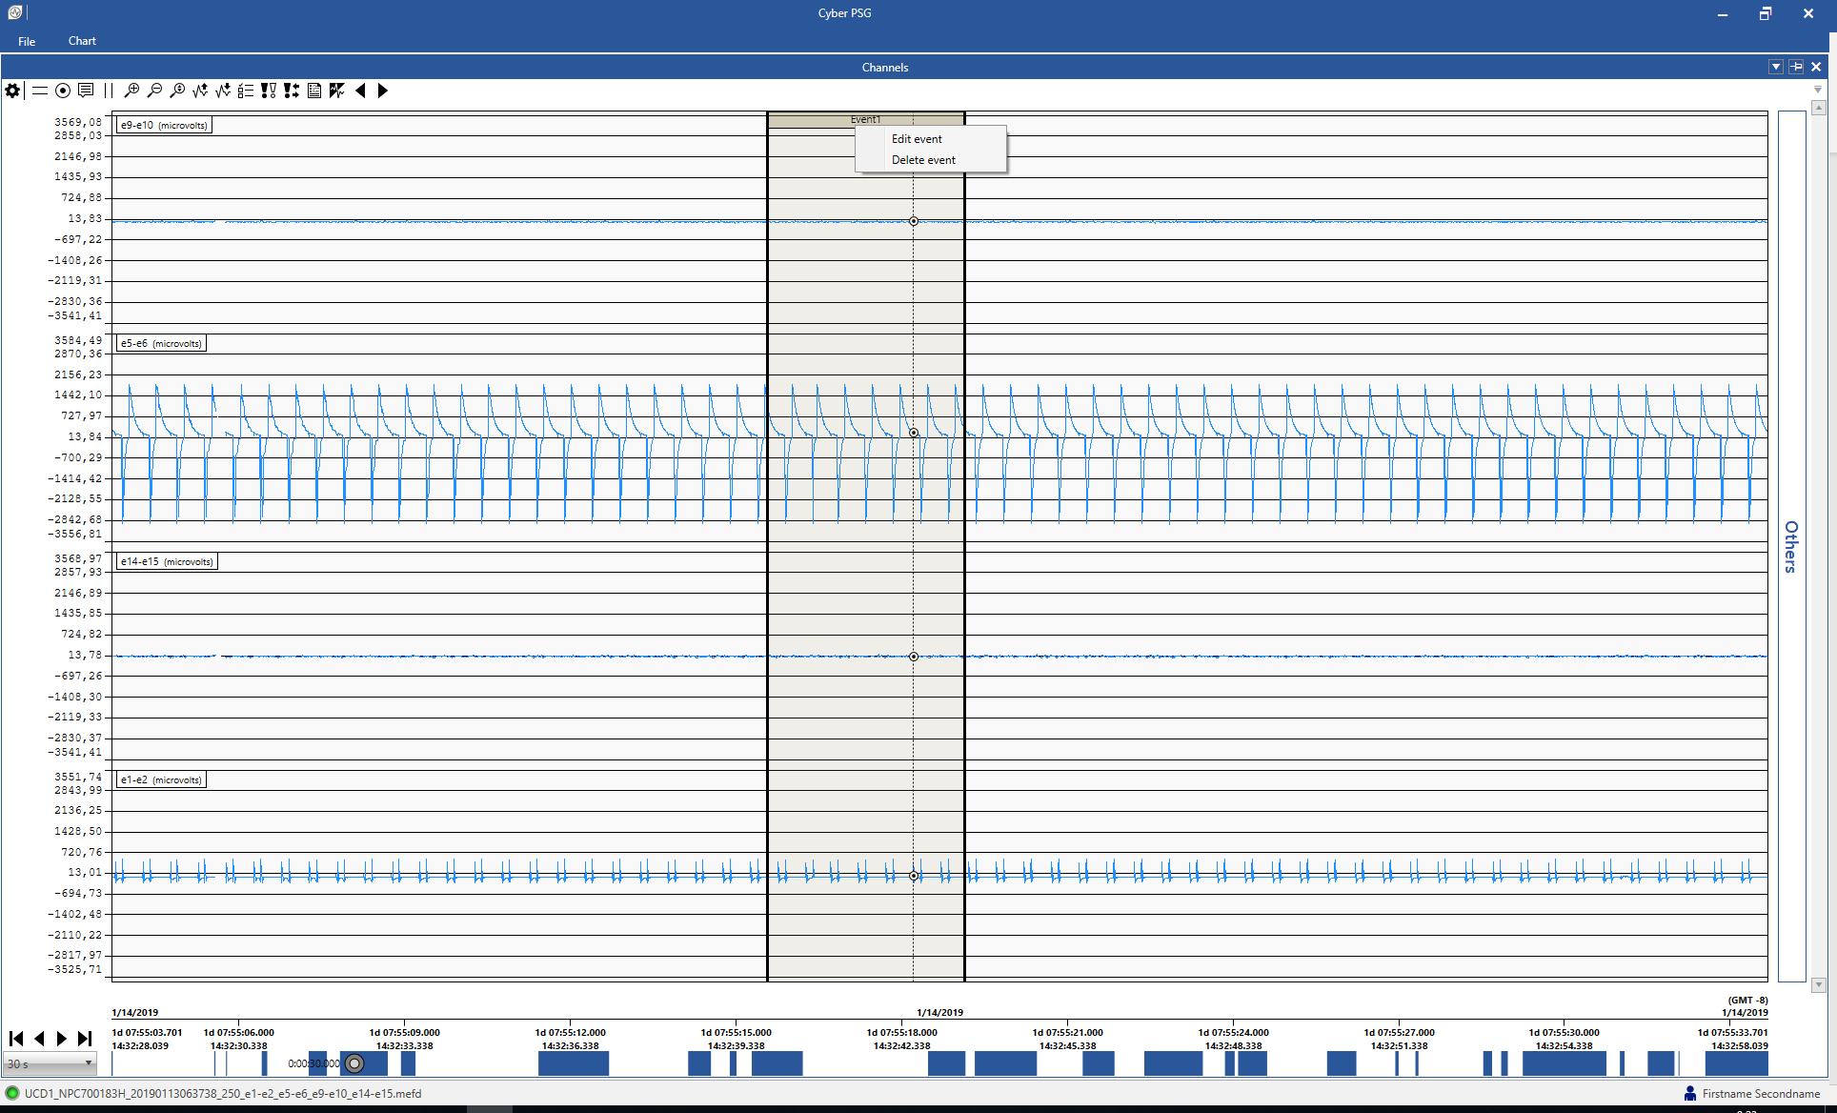

1. Left click on header of an annotation and drag it to move it to a different position.
2. The order of overlapping annotations can be changed using the mouse wheel. If the annotation is hidden behind the another one, use the mouse wheel while pointing at the header of annotations to bring it forth.

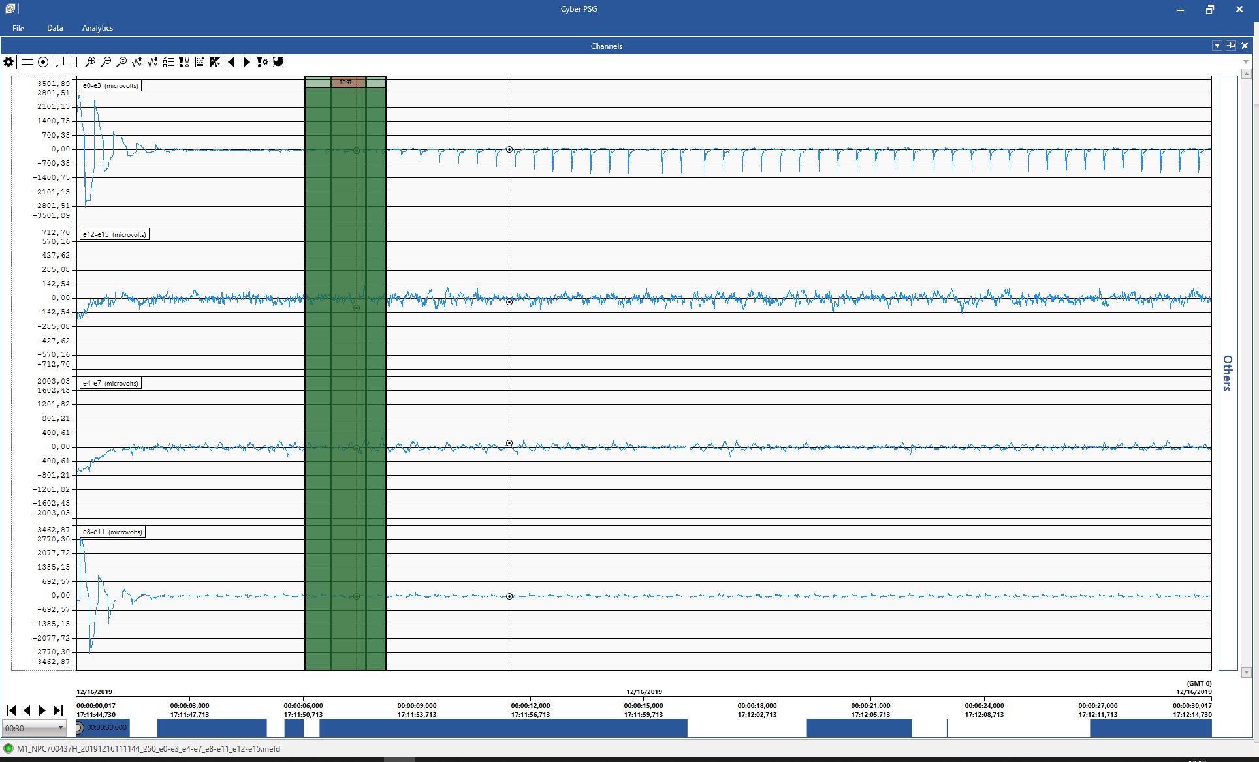

## Annotation navigator

To open a dockable window with Annotation Navigator, select Data->Annotation Navigator in Ribbon menu.

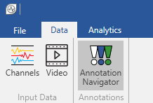

Annotation navigator window contains a list of all annotations with applied annotation filters. When the user clicks on any annotation, a jump in data to the that annotation is performed.

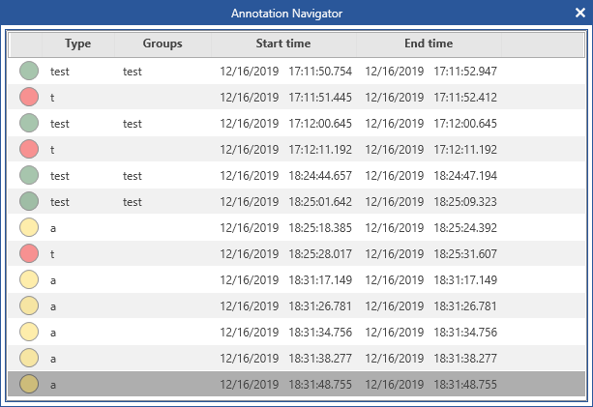

# Filters

CyberPSG allows to apply high pass, low pass and notch filters to filter the displayed data. These filters can be applied to a single channel or to multiple channels with the same frequency.

1. To apply a data filter, click on the Filter manager icon in the Channels top menu.



1. Choose one or more channels or group of channels with same sampling frequency to apply filter on one or more channels by one move.

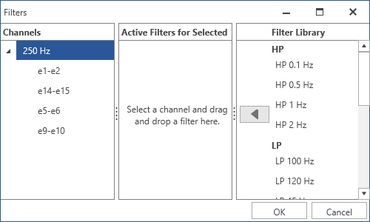

1. To add filter
   1. Choose a filter from the Filter Library and press Add filter button.

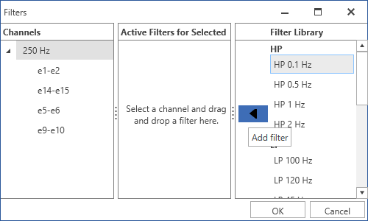

* 1. Alternatively, Drag & Drop selected a filter to the Active filters section.

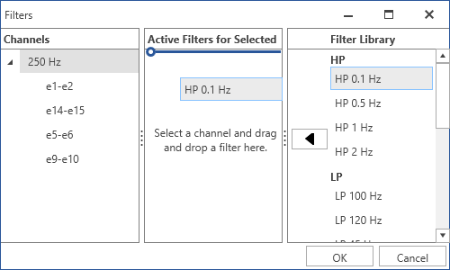

1. Active filters section shows filters that are the same for all selected channels. Filter that is unique just for one channel is displayed only when this specific channel is selected.
2. Filter Library shows filters applicable for selected channels and that are not applied for all selected channels.
3. Click on Remove filter button to remove it for selected channels.

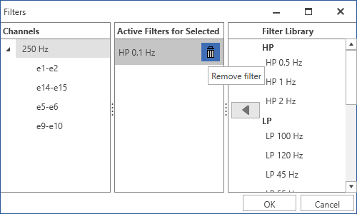

1. Confirm the selection of filters with the OK button.

# Analytics

CyberPSG allows to perform analysis over a selected area in data. To select an area in data for the analysis, left-click on a chart and then left-click while holding shift on another area in the chart. It is possible to change the end of the selected area by another left-click while holding shift. The selected area is cleared when another left-click (without holding shift) is performed, when visible range on X axis is changed or when a move in data is performed.

It is possible to perform 3 type of analysis, separately or together, based on the user needs: Small data analysis, FFT calculation and Spectrogram calculation.

## Small data analysis

Selecting an area for analysis will display a tooltip window with a computed small data analysis. The small data analysis is computed only for a selected channel, this selection is done based on the position of the first left-click. Tooltip window is closed when the selected area is cleared.

The small data analysis shows the Maximum and Minimum values, Time of Maximum and Minimum, Peak to peak amplitude, Time between peaks in microseconds, Mean, Median, Standard deviation and Range of the selected area (in time length).

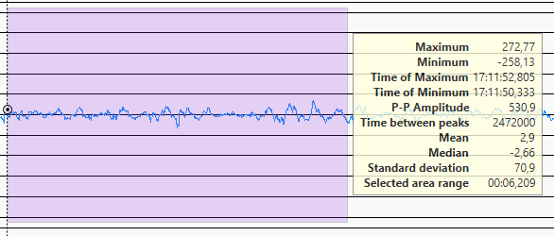

## FFT

To be able to display a FFT calculation, open the FFT window: Analytics -> FFT in the Ribbon menu.

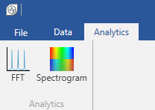

To perform a calculation, select an area in data. The results will be displayed in the FFT window when the computation is finished.

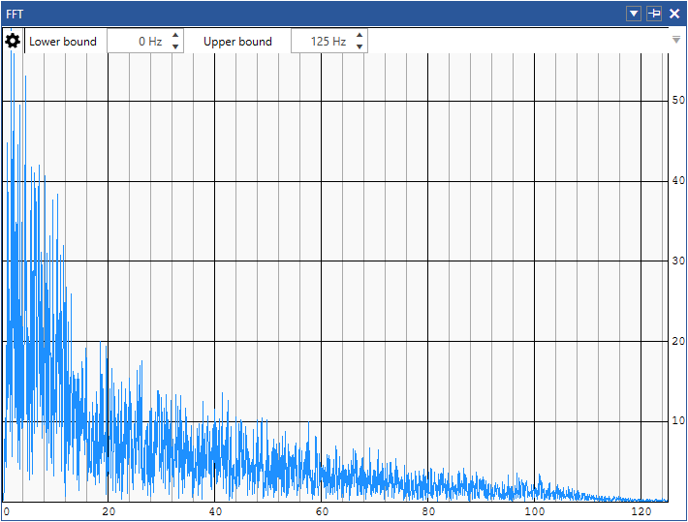

It is possible to set Lower and Upper frequency bounds to get more accurate results.

## Spectrogram

To be able to display a Spectrogram, open the Spectrogram window: Analytics -> Spectrogram in the Ribbon menu.



The Spectrogram window offers several parameters that should be set before the data are selected.

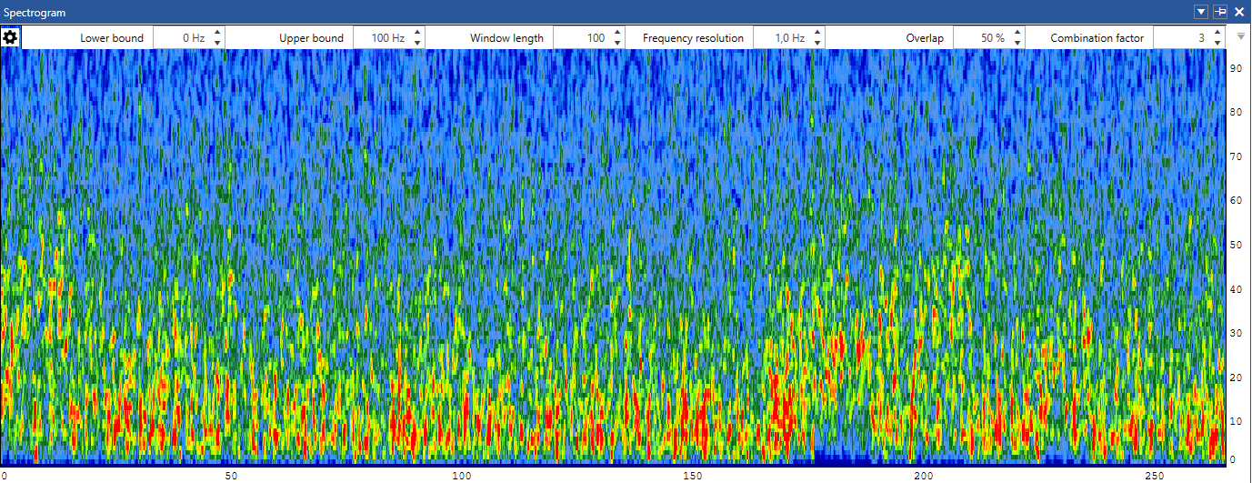

**Window length** - Specifies how long data segment is taken from a signal to the window.

**Frequency resolution** - Specifies the resolution on the Y axis. If the frequency resolution results in a wider window than the window length parameter, the window is zero-padded to satisfy the frequency resolution. If the window length is wider than the one that results from the frequency resolution, the window length is taken instead of the frequency resolution.

**Overlap** - Specifies a percentage part of the window that is overlapped by the next one. The next window overlaps just the real data from previous window and not the zero-pads.

**Combination factor** - Specifies how many neighboring FFT spectra is averaged out to create one spectrogram column.

Note: The length of the selected area and parameters setting might greatly affect the calculation time.

Lower and Upper frequency bounds can be changed after the spectrogram is calculated.

To perform a calculation, select an area in data. The results will be displayed in the Spectrogram window when the computation is finished.

# Converting data and annotations from JSON file formats to MEF3 and XML

MEF3 is a native data format for CyberPSG application. Currently, CyberPSG does not support any other format of the data to be loaded into the application. Based on data from Mayo Clinic, Certicon has created a convertor to convert raw data (accelerometer, EEG) from JSON format that is generating while capture data from Summit RC+S devices. The convertor also converts recorded JSON Summit RC+S annotations to XML format that can be imported to CyberPSG. See the steps below describing how to use the RC+S JSON to MEF and XML convertor.

Note: This feature is only for debugging and research purposes and Certicon is not liable for any consequences arising from using this feature. The owneer of data is solely responsible for ensuring that the data and annotations converted to the Certicon CyberPSG viewer comply with data in JSON format.

1. Go to External Tools -> Data Converter to run the converter from JSON to MEF3 and XML

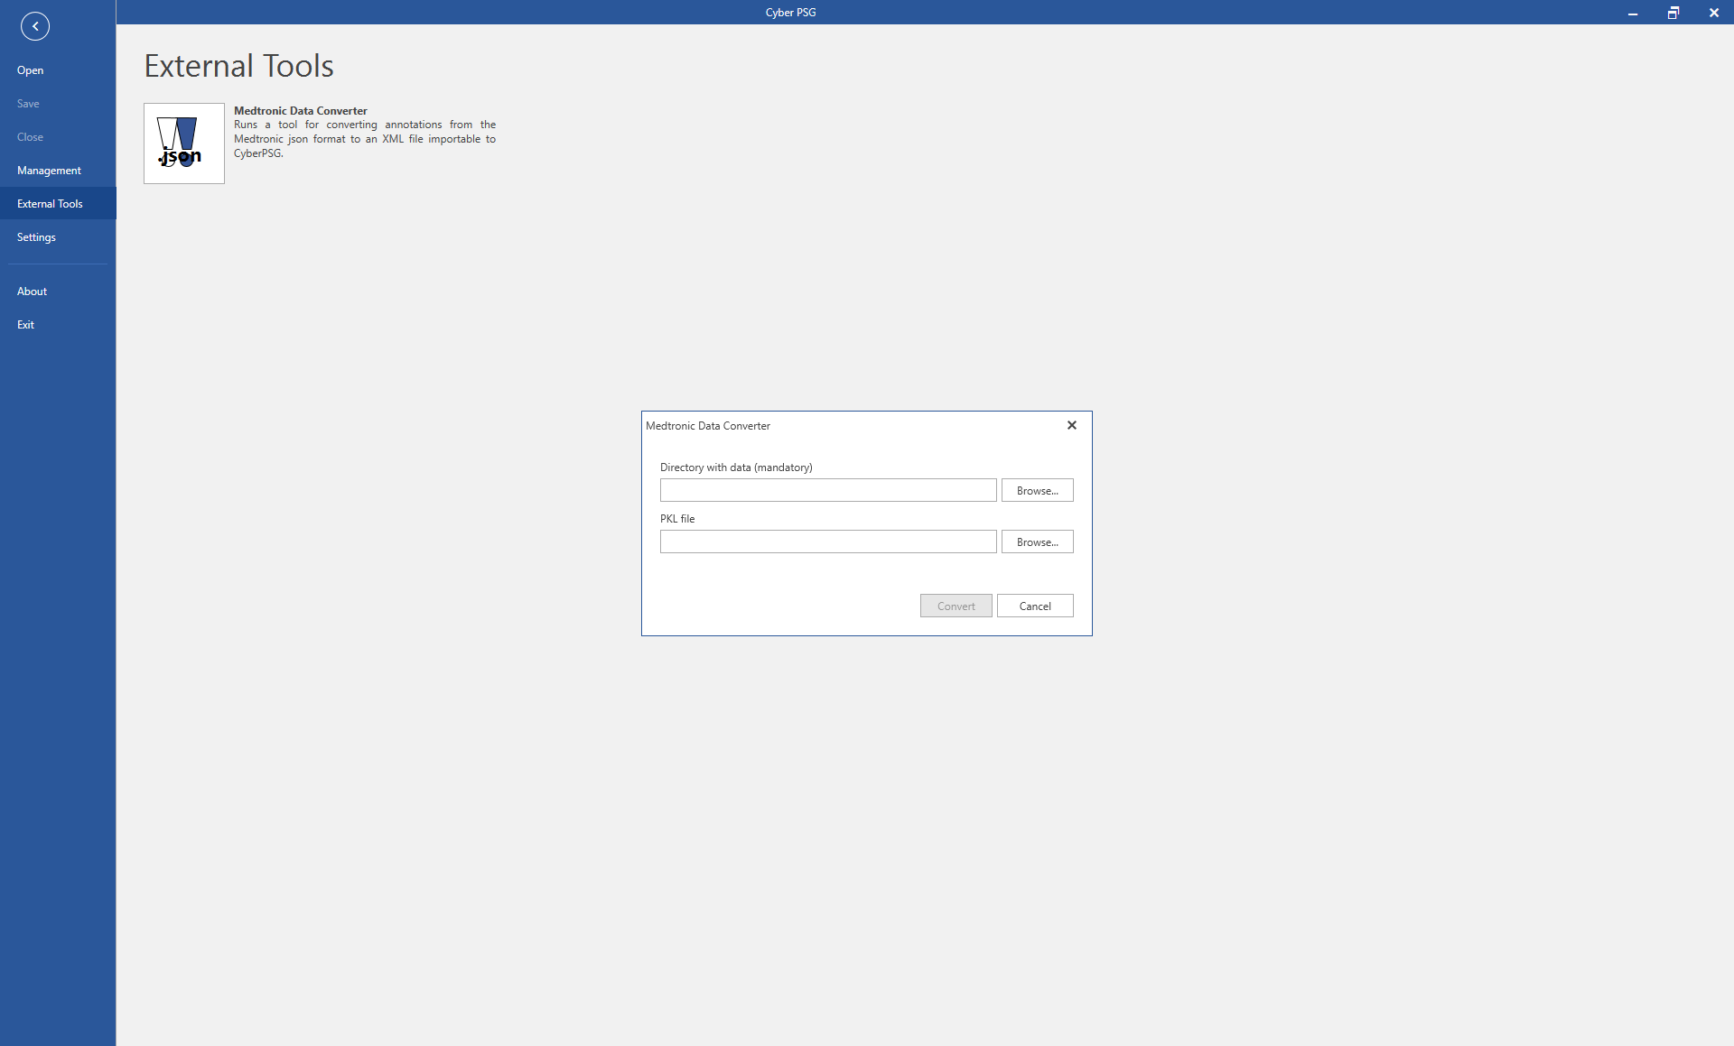

1. When conversion is finished, open the MEF data as described in section Data
2. Converted annotations in XML format can be imported as described in section Annotation management

The MEF data are password protected using “pass” as the default password.

# Settings

Video folder and Channels settings are set in Settings section. User can also Export/Import montages, active filters, video and channels settings here.

## Export

Go to Settings -> Export to export montages, filters and settings to an xml file. Filters can be exported only when a session is opened.

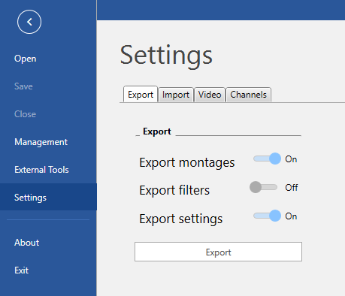

## Import

Go to Settings -> Import to import montages, filters and settings from an xml file. Filters can be imported only when a session is opened.

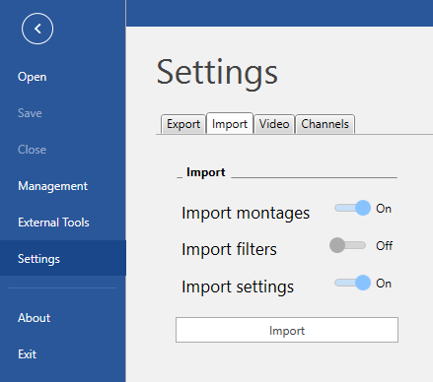

## Video

Go to Settings -> Video to set the path to Video folder.

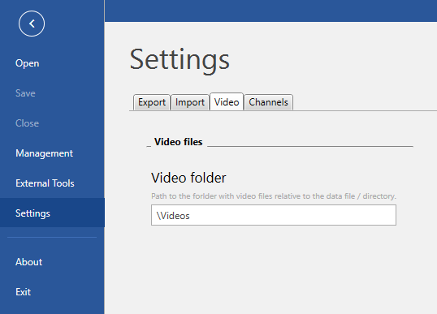

## Channels

Go to Settings -> Channels to change the channel settings.

